Lab Exercise 9
Setting up Poll SCM Configuration in Jenkins

Objective: To set up poll SCM configuration in Jenkins for automating build triggering and optimizing resource usage on Jenkins servers

Tools required: Jenkins

Prerequisites: You need to have a Jenkins up and running.

Steps to be followed:
- Log in to the Jenkins CI tool and set up poll SCM configuration

Step 1: Log in to the Jenkins CI tool and set up poll SCM configuration

- Log in to Jenkins using the credentials

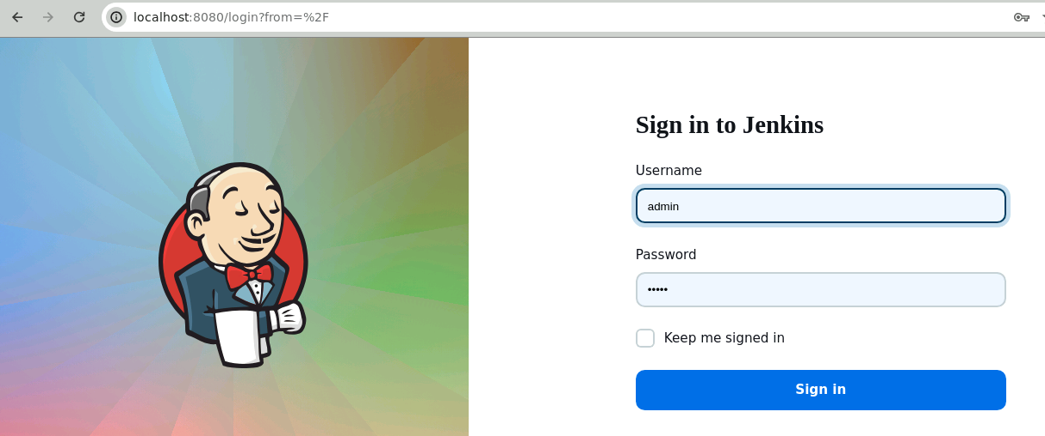

Note: The credentials for accessing Jenkins in the lab are Username: admin and Password: admin.

- In the Jenkins dashboard, click on New Item

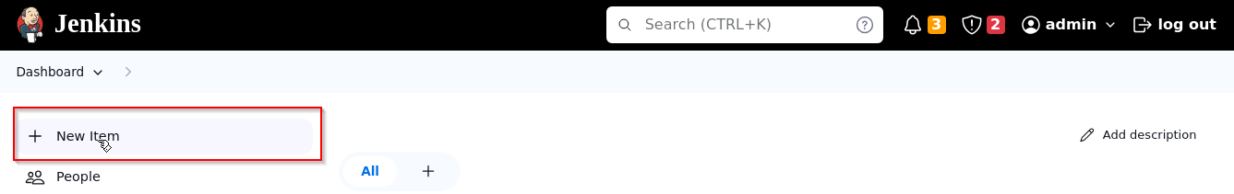

- Select the Freestyle project while creating a Jenkins job, provide a custom job name, and click on OK

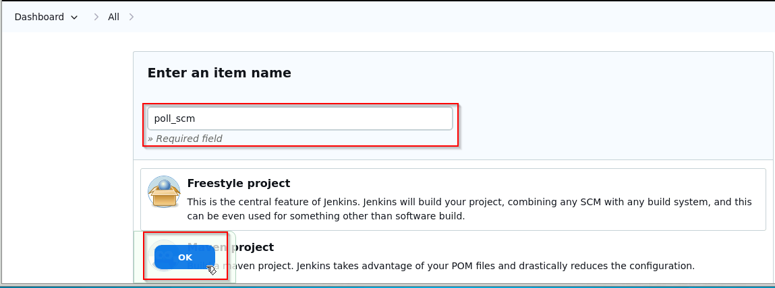

Output:
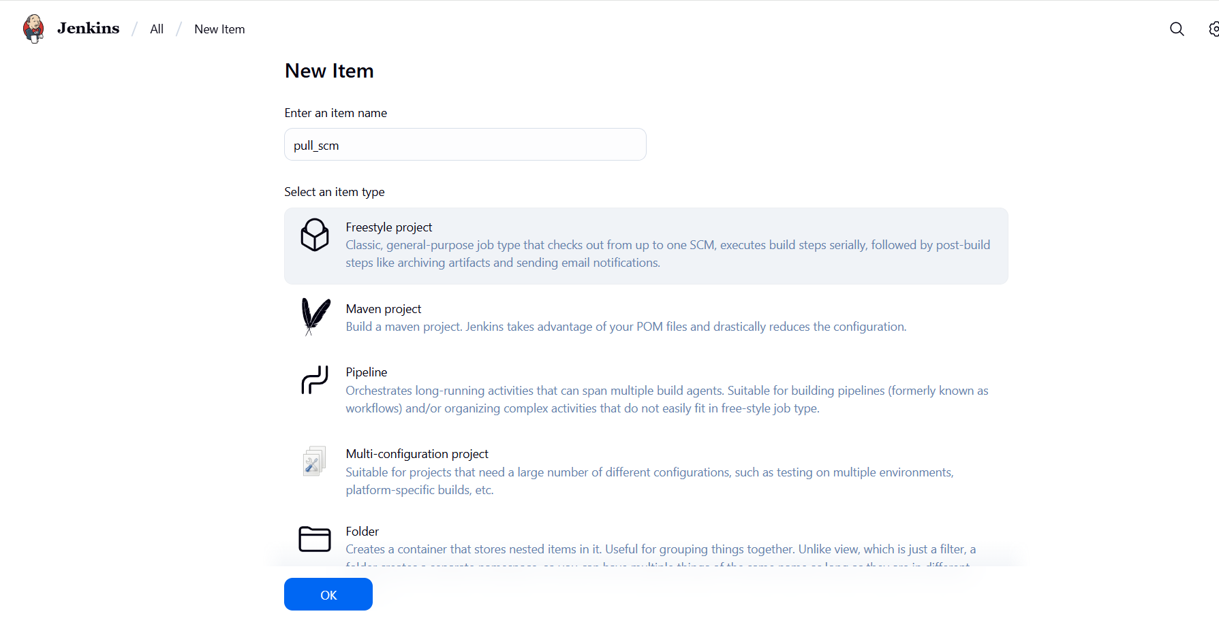

- Now, in the Configure page, navigate to Source Code Management from the left navigation bar, select Git, and then provide the Git repository URL

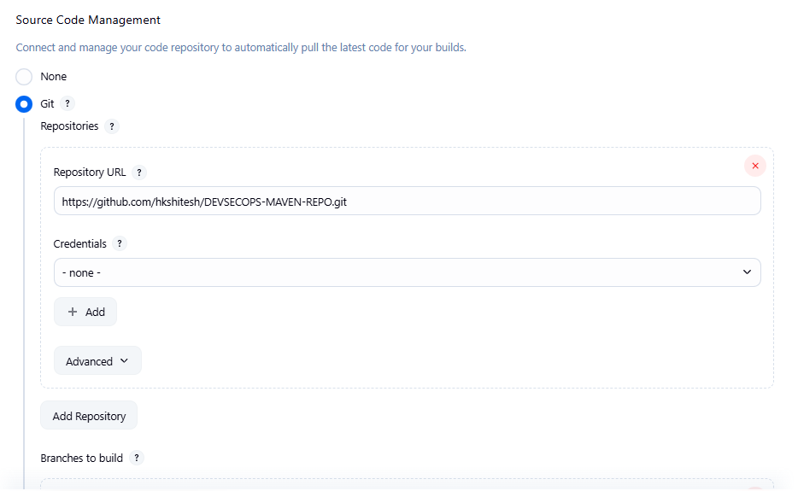

Note: Here, the repository URL is https://github.com/hkshitesh/DEVSECOPS-MAVEN-REPO.git

- Now, navigate to Build Environment, click on Poll SCM, provide H/2**** under the Schedule section, and then click on Save

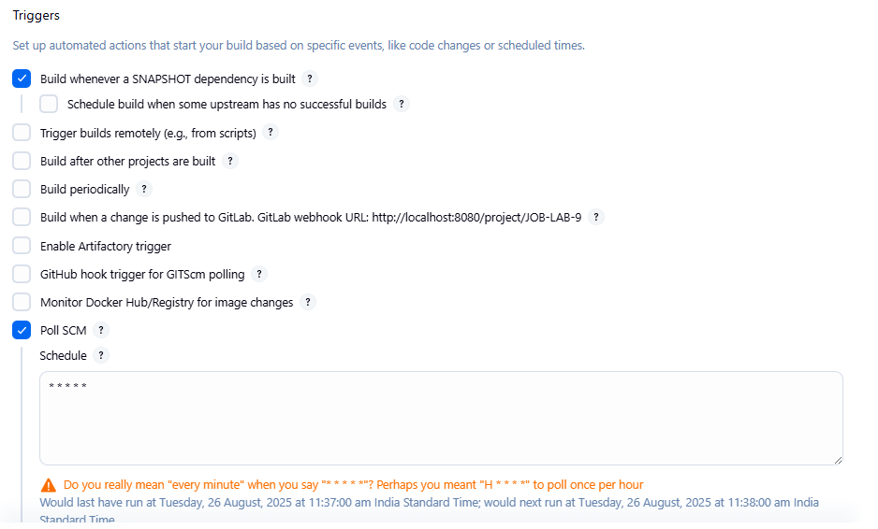
Output:
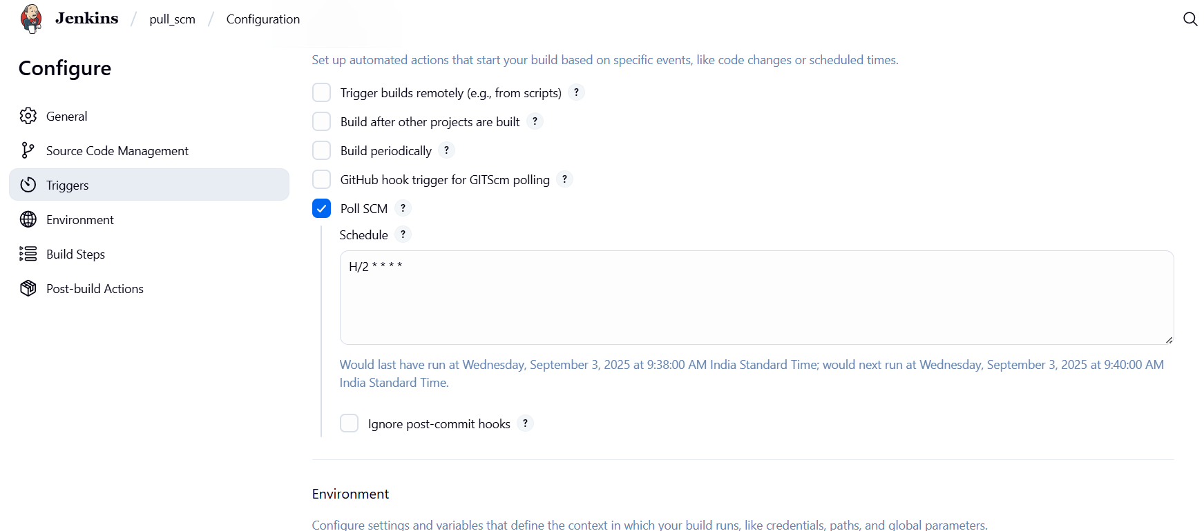

- Then, click on Build Now to configure a build, and you will be able to view the successful build in the Console output section.

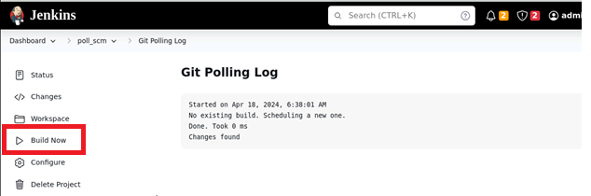

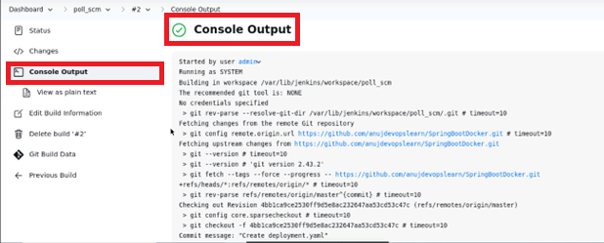

You can see that the build is configured successfully.

By following these steps, you have successfully set up poll SCM configuration in Jenkins for automating build triggering and optimizing resource usage on Jenkins servers.
Output:
